13.2 Getting your bearings

Sprint 13 Incident Investigation

← Use the Document tabs to locate the notes for each task in this investigation.

13.2.1 Device

13.2.1 Finding the attacking device
Instructions for completing this task are located here. Use this worksheet to keep notes as you complete it.

iindex=client1 hostname=imreallynotbatman.com returns traffic results with ip of 100% from 192.168.250.70:80 and ip of 40.80.148.42 and 23.22.63.114 to 1000’s of ports in 45 minutes total. Highest spike is 2000+ hits from 40.80.148.42 from 65 different ports all traffic locally comes through internal3 on port 80

Top item accessed is /index.php/component/search at /jomla/index.php

To clarify, the GET requests come from 40.80.148.42 and 23.22.63.114 - signifying the attackers ip

index=client1 sourcetype=suricata dest_ip="40.80.148.42"

Suricata IDS logs show events with ip of 40.80.148.42 at multiple ports with user agent string Mozilla\/5.0 (Windows NT 6.1; WOW64; Trident\/7.0; rv:11.0) like Gecko

13.2.2 Tool

13.2.2 Determining the tool
Instructions for completing this task are located here. Use this worksheet to keep notes as you complete it.

index=client1 Mozilla/5.0 (Windows NT 6.1; WOW64) AppleWebKit/537.21 (KHTML, like Gecko) Chrome/41.0.2228.0 Safari/537.21 http_method=GET" = user_agent most present in all hits. Correlates with known vulnerability scanning tool

src_headers: GET /joomla/index.php/component/mailto/?link=57e1ada6273ce1407e3ff09366bf80b5f2e47ac0&template=protostar&tmpl=r1Gy6eoF'));select%20pg_sleep(10);%20--%20 HTTP/1.1
X-Requested-With: XMLHttpRequest
Referer: http://imreallynotbatman.com:80/
Cookie: ae72c62a4936b238523950a4f26f67d0=v7ikb3m59romokqmbiet3vphv3
Host: imreallynotbatman.com
Connection: Keep-alive
Accept-Encoding: gzip,deflate
User-Agent: Mozilla/5.0 (Windows NT 6.1; WOW64) AppleWebKit/537.21 (KHTML, like Gecko) Chrome/41.0.2228.0 Safari/537.21
Acunetix-Product: WVS/10.0 (Acunetix Web Vulnerability Scanner - Free Edition)
Acunetix-Scanning-agreement: Third Party Scanning PROHIBITED
Acunetix-User-agreement: http://www.acunetix.com/wvs/disc.htm
Accept: */*

13.2.3 Exploited CMS

13.2.3 Identifying the exploited CMS
Instructions for completing this task are located here. Use this worksheet to keep notes as you complete it.

Http:stream searches reveal Joomla directory paths on GET and POST requests.

index=client1 imreallynotbatman.com sourcetype="stream:http" http_method=GET

13.2.4 Defacement image’s filename

13.2.4 Establishing the defacement image’s filename
Instructions for completing this task are located here. Use this worksheet to keep notes as you complete it.

index=client1 sourcetype="stream:http" c_ip="192.168.250.70" | stats count by uri reveals these results

uri | count
/core/extensions/com_joomlaupdate.xml | 1
/core/list.xml | 190
/css?family=Open Sans | 195
/jed/list.xml | 182
/msdownload/update/v3/static/trustedr/en/disallowedcertstl.cab?927db53f6e77b785 | 193
/poisonivy-is-coming-for-you-batman.jpeg | 2

Cross referencing Suricata logs confirms strange image filename triggering alerts

2016-08-10 22:21:18.931 | /joomla/images/imnotbatman.jpg | /joomla/images/imnotbatman.jpg
2016-08-10 22:19:11.351 | /poisonivy-is-coming-for-you-batman.jpeg

{"timestamp":"2016-08-10T16:19:11.351981-0600","flow_id":3326219642,"in_iface":"eth1","event_type":"http","src_ip":"192.168.250.70","src_port":51573,"dest_ip":"23.22.63.114","dest_port":1337,"proto":"TCP","tx_id":0,"http":{"hostname":"prankglassinebracket.jumpingcrab.com","url":"\/poisonivy-is-coming-for-you-batman.jpeg","http_content_type":"image\/jpeg","http_method":"GET","protocol":"HTTP\/1.0","status":200,"length":553879}}
Show syntax highlighted
- host = suricata-ids.waynecorpinc.local
- index = client1
- source = /var/log/suricata/eve.json
- sourcetype = suricata
s

13.2.5 FQDN

13.2.5 Associating the malicious FQDN
Instructions for completing this task are located here. Use this worksheet to keep notes as you complete it.

Searching for malicious file name across suricata and http streams returns image name linked to suspicious hostname

http.hostname
http.hostname
Selected Yes No
1 Value, 57.143% of events

Reports
Top values Top values by time Rare values
Events with this field
Values Count %
prankglassinebracket.jumpingcrab.com 4 100%

{"timestamp":"2016-08-10T16:17:46.942205-0600","flow_id":1172520240,"in_iface":"eth1","event_type":"http","src_ip":"192.168.250.70","src_port":63139,"dest_ip":"23.22.63.114","dest_port":1337,"proto":"TCP","tx_id":0,"http":{"hostname":"prankglassinebracket.jumpingcrab.com","url":"\/poisonivy-is-coming-for-you-batman.jpeg","http_method":"GET","protocol":"HTTP\/1.0","length":0}}

Searches of prankglassinebracket.jumpingcrab.com return results pointing to host_addr 23.22.63.114 and dest_ip of 8.8.8.8

{"endtime":"2016-08-10T22:06:21.440131Z","timestamp":"2016-08-10T22:06:21.440125Z","host_addr":["23.22.63.114","23.22.63.114"],"name":["prankglassinebracket.jumpingcrab.com","prankglassinebracket.jumpingcrab.com"],"reply_code":["NoError","NoError"],"response_time":[62480,62486],"transaction_id":55247,"ttl":[3599,32768,3599,32768],"bytes":162,"src_ip":"192.168.250.20","src_mac":"00:0C:29:C3:C4:00","src_port":54421,"bytes_in":0,"dest_ip":"8.8.8.8","dest_mac":"08:5B:0E:93:92:AF","dest_port":53,"bytes_out":162,"time_taken":6,"transport":"udp"}

Fortigate firewall searches reveal the resolved ip address from the DNS query

index=client1 sourcetype=fortigate_traffic OR sourcetype=fortigate_utm dest_ip="23.22.63.114"

Aug 10 16:06:21 192.168.250.1 date=2016-08-10 time=16:06:21 devname=gotham-fortigate devid=FGT60D4614044725 logid=0317013312 type=utm subtype=webfilter eventtype=ftgd_allow level=notice vd="root" policyid=10 sessionid=928318 user="" srcip=192.168.250.70 srcport=56504 srcintf="internal3" dstip=23.22.63.114 dstport=1337 proto=6 service=HTTP hostname="prankglassinebracket.jumpingcrab.com:1337" profile="monitor-all" action=passthrough reqtype=direct url="/poisonivy-is-coming-for-you-batman.jpeg" sentbyte=106 rcvdbyte=0 direction=N/A msg="URL belongs to an allowed category in policy" method=domain cat=26 catdesc="Malicious Websites" crscore=30 crlevel=high

13.2.6 Pre-staging IP

13.2.6 Discovering the pre-staging IP address
Instructions for completing this task are located here. Use this worksheet to keep notes as you complete it.

Locating the FQDN in the previous step searches returned the IP for the staging server

GET requests were sent from imreallynotbatman.com Ip address to prankglassinebracket.jumpingcrab.com to retrieve sus filename, revealing the IP of the host of the file - 23.22.63.114 Is corroborated over each step of the previous step.

VirusTotal returned these results hitting on prankglassinebracket.jumpingcrab.com and po1s0n1vy.com

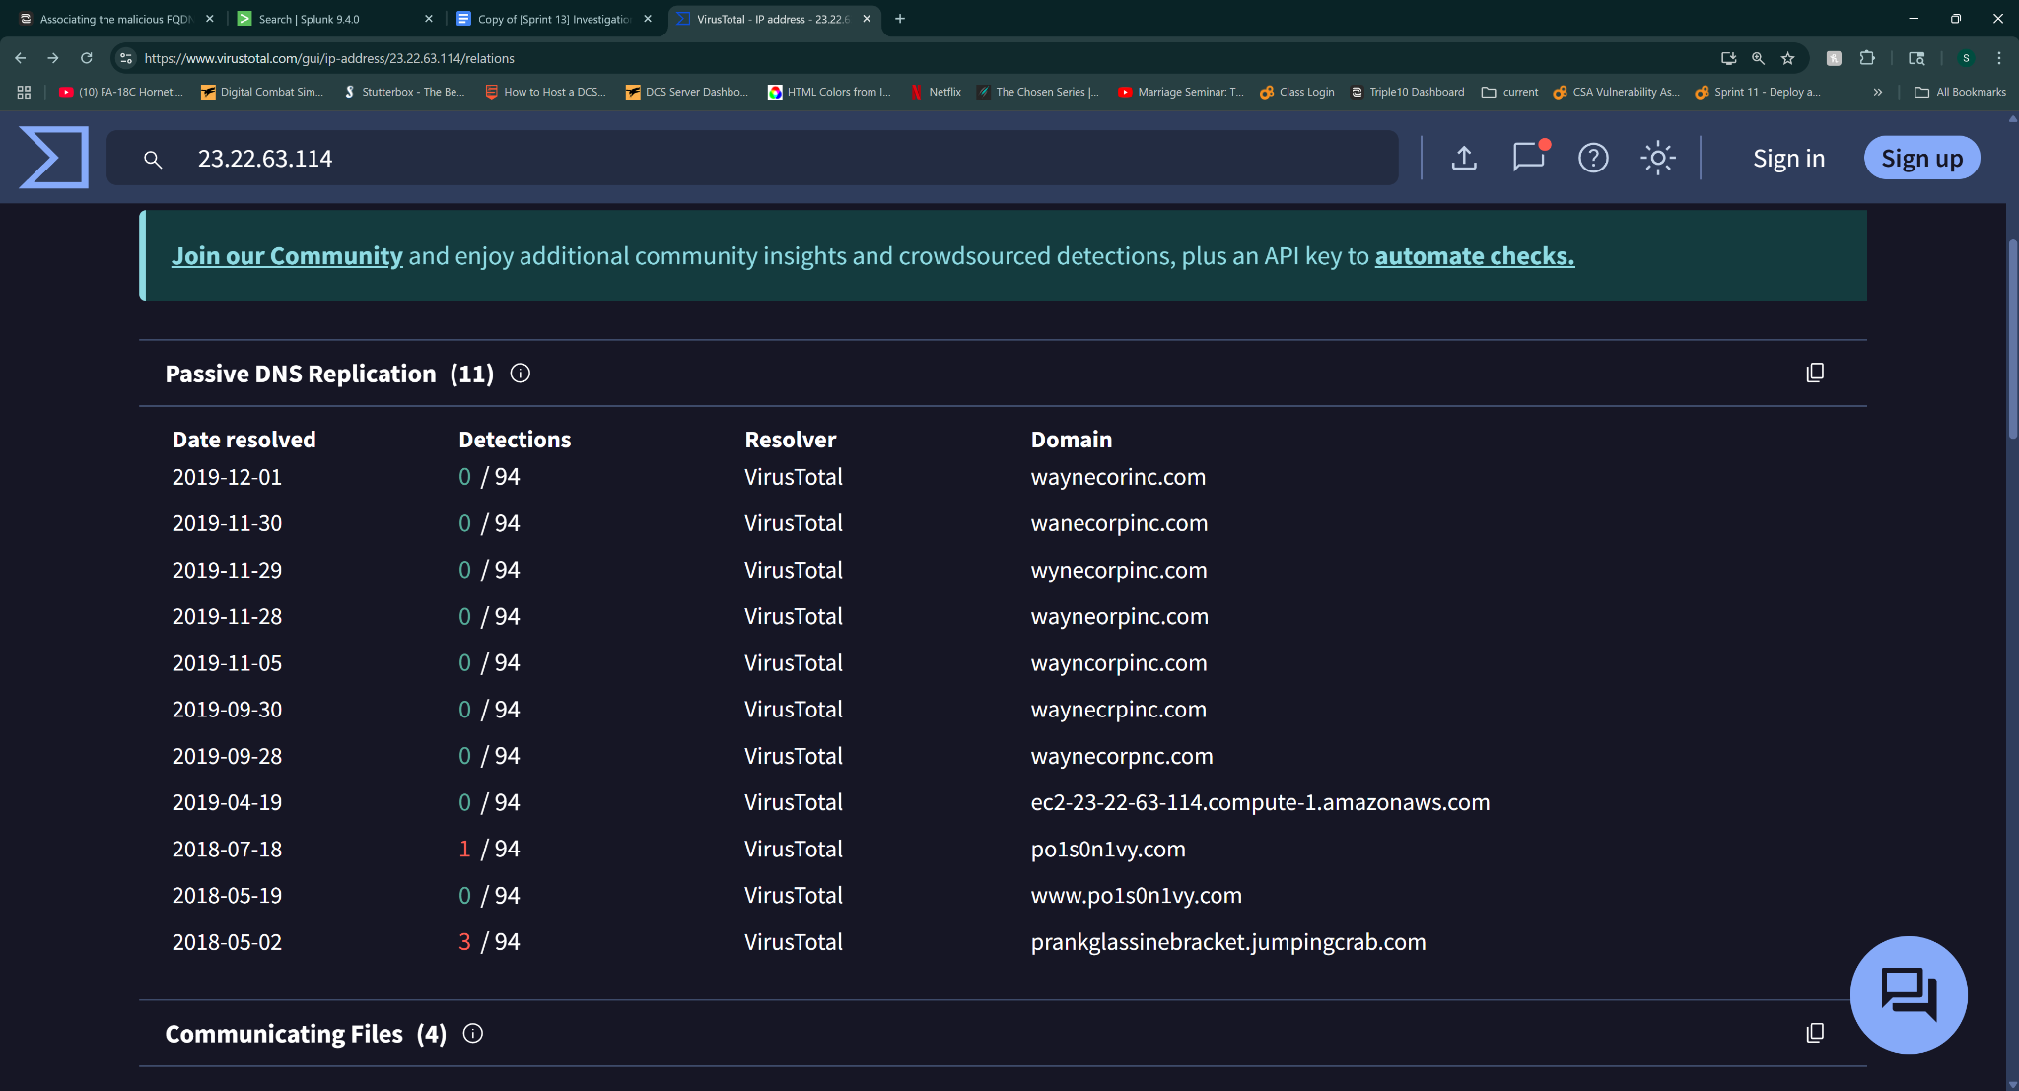
Investigation of domain also related to Hostname IP address
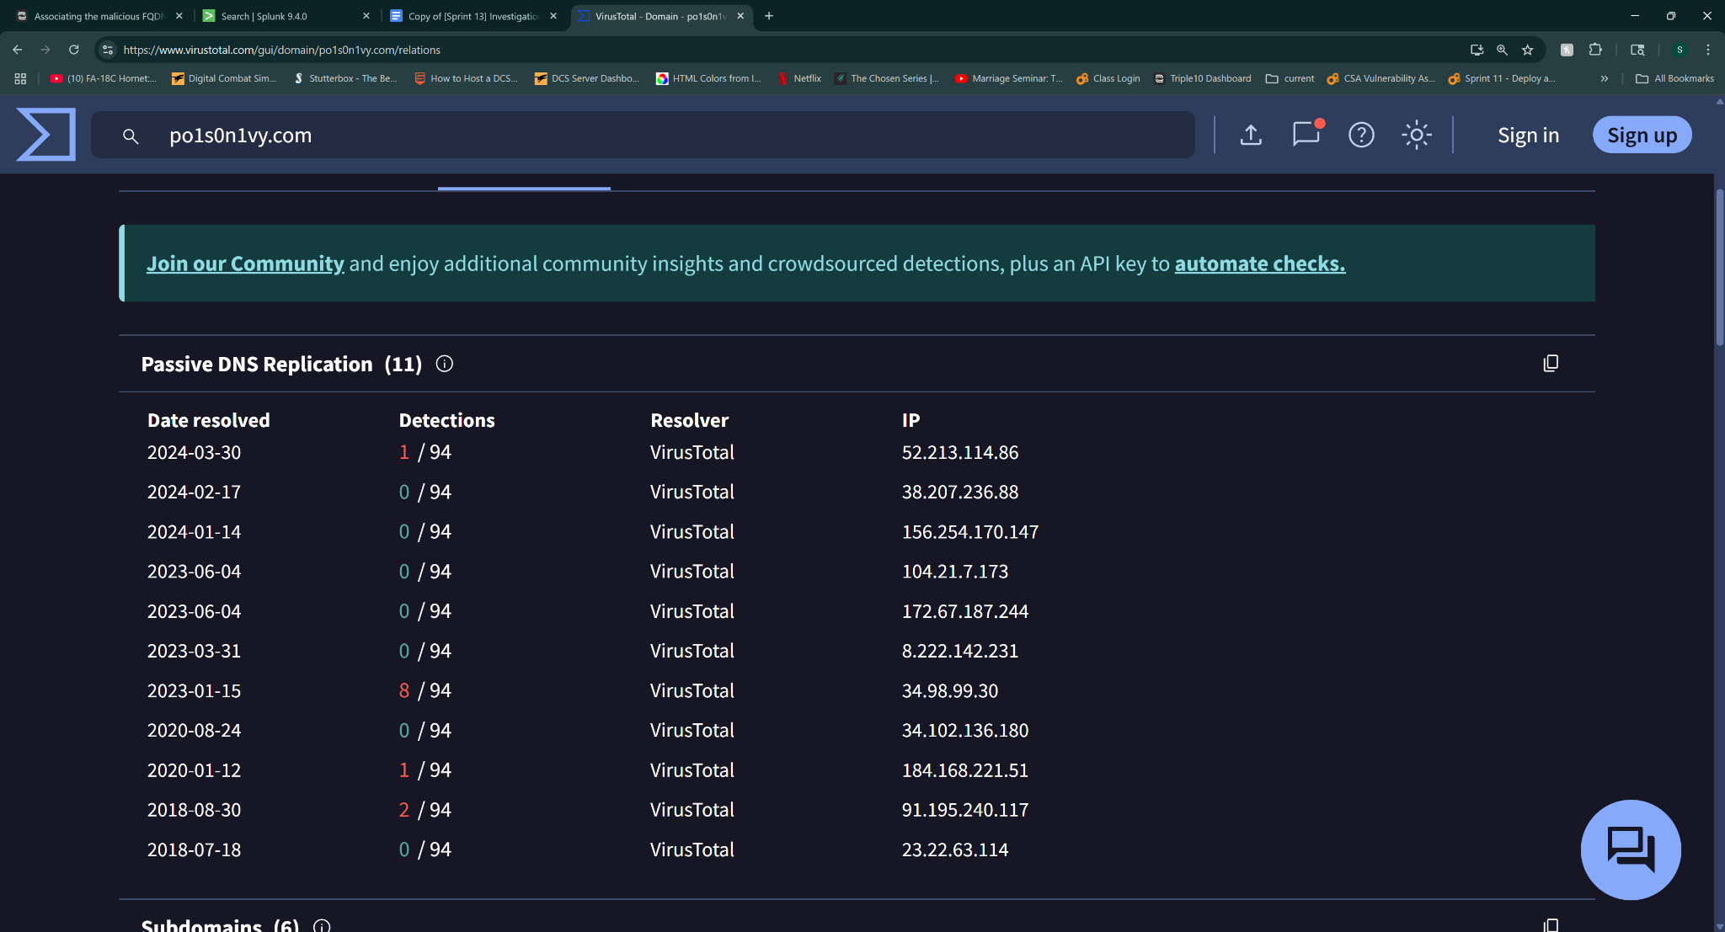

13.2.7 APT email

13.2.7 Using OSINT to confirm the APT group’s email address
Instructions for completing this task are located here. Use this worksheet to keep notes as you complete it.

Searches of the domain po1s0n1vy.com on whoxy.com revealed a common email address associated with repeated registrars of the domain

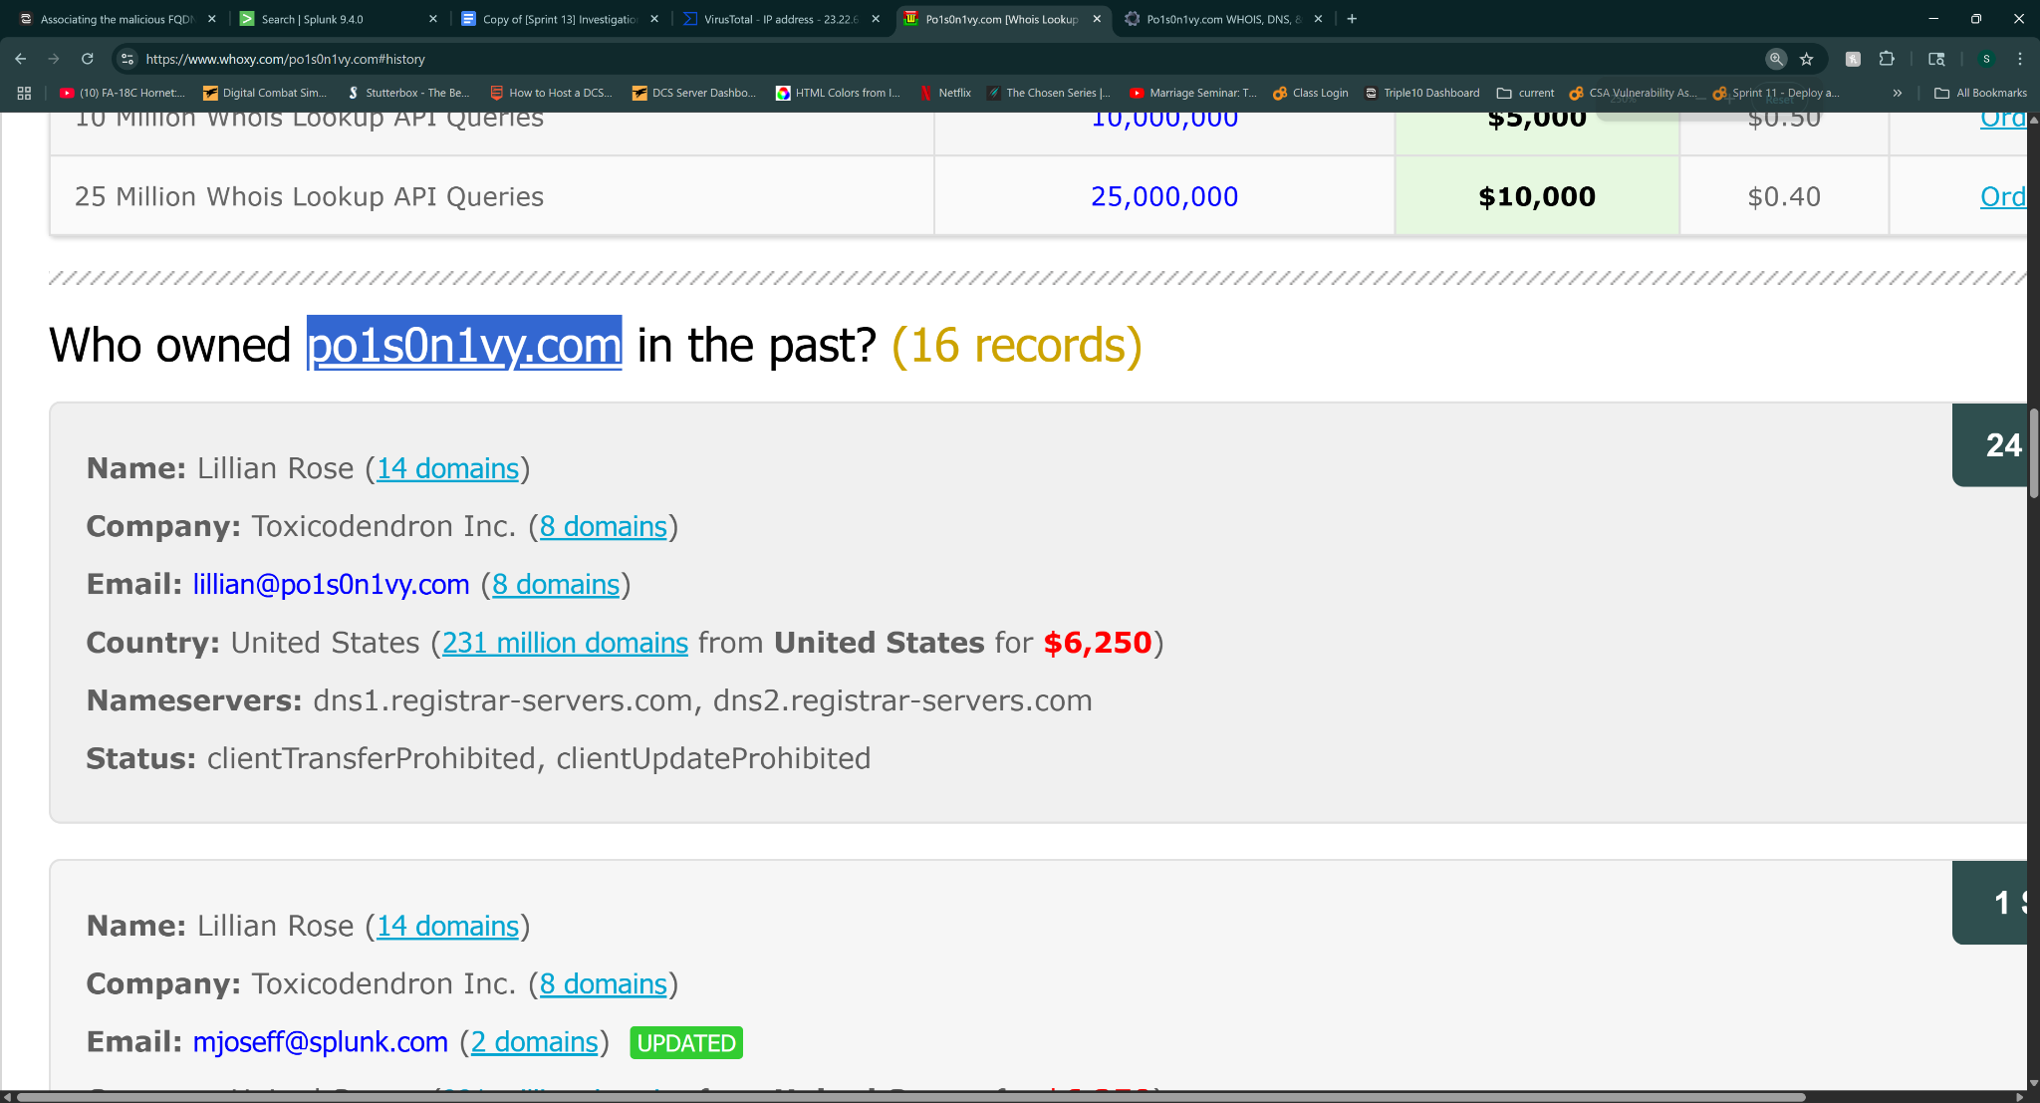

A common name Lillian Rose with email lillian@po1s0n1vy.com appears in one or two variations

13.2.8 Brute-force IP

13.2.8 Assessing the brute-forcing IP address
Instructions for completing this task are located here. Use this worksheet to keep notes as you complete it.

Searching for POST events for the domain imreallynotbatman.com that contain username and passwd form_data yielded 400+ events from 23.22.63.114 - excluding results that contain header information “Acunetix”

index=client1 sourcetype="stream:http" http_method="POST" dest_ip="192.168.250.70" NOT "Acunetix" form_data="*username*passwd*"

Stat count by src_ip showed 412 results for 23.22.63.114 and a single entry for 40.80.148.42

40.80.148.42 had a successful login attempt with “admin, batman”

13.2.9 Malware filename

13.2.9 Figuring out the malicious executable’s filename
Instructions for completing this task are located here. Use this worksheet to keep notes as you complete it.

Searching through POST http logs reveals a potential malicious .exe file while excluding vuln scanners

index=client1 sourcetype="stream:http" http_method="POST" dest_ip="192.168.250.70" NOT "Acunetix" *.exe*

part_filename() reveals 3791.exe

Sysmon logs confirm file was ran on host machine by searching for EventID 1 for 3791.exe

index=client1 source="WinEventLog:Microsoft-Windows-Sysmon/Operational" 3791.exe EventID=1

13.2.10 MD5 hash

13.2.10 Locating the MD5 hash of that executable
Instructions for completing this task are located here. Use this worksheet to keep notes as you complete it.

index=client1
sourcetype=xmlwineventlog
source="WinEventLog:Microsoft-Windows-Sysmon/Operational"
| rex max_match=1 "<EventID>(?<EventID>\d+)</EventID>"
| search EventID=1
| rex max_match=1 "<Data Name='CommandLine'>(?<CommandLine>[^<]+)"
| search CommandLine="*3791.exe*"
| table _time host User Image CommandLine

AAE3F5A29935E6ABCC2C2754D12A9AF0

<Event xmlns='http://schemas.microsoft.com/win/2004/08/events/event'><System><Provider Name='Microsoft-Windows-Sysmon' Guid='{5770385F-C22A-43E0-BF4C-06F5698FFBD9}'/><EventID>1</EventID><Version>5</Version><Level>4</Level><Task>1</Task><Opcode>0</Opcode><Keywords>0x8000000000000000</Keywords><TimeCreated SystemTime='2016-08-10T21:56:18.142461700Z'/><EventRecordID>428908</EventRecordID><Correlation/><Execution ProcessID='1296' ThreadID='1416'/><Channel>Microsoft-Windows-Sysmon/Operational</Channel><Computer>we1149srv.waynecorpinc.local</Computer><Security UserID='S-1-5-18'/></System><EventData><Data Name='UtcTime'>2016-08-10 21:56:18.142</Data><Data Name='ProcessGuid'>{E500B0EA-A302-57AB-0000-00108D65C301}</Data><Data Name='ProcessId'>3880</Data><Data Name='Image'>C:\inetpub\wwwroot\joomla\3791.exe</Data><Data Name='CommandLine'>3791.exe </Data><Data Name='CurrentDirectory'>C:\inetpub\wwwroot\joomla\</Data><Data Name='User'>NT AUTHORITY\IUSR</Data><Data Name='LogonGuid'>{E500B0EA-219E-57AA-0000-0020E3030000}</Data><Data Name='LogonId'>0x3e3</Data><Data Name='TerminalSessionId'>0</Data><Data Name='IntegrityLevel'>High</Data><Data Name='Hashes'>SHA1=65DF73D77324D008C83C3E57B445DF0FD43A3A51,MD5=AAE3F5A29935E6ABCC2C2754D12A9AF0,SHA256=EC78C938D8453739CA2A370B9C275971EC46CAF6E479DE2B2D04E97CC47FA45D,IMPHASH=481F47BBB2C9C21E108D65F52B04C448</Data><Data Name='ParentProcessGuid'>{E500B0EA-A302-57AB-0000-00102E63C301}</Data><Data Name='ParentProcessId'>2896</Data><Data Name='ParentImage'>C:\Windows\SysWOW64\cmd.exe</Data><Data Name='ParentCommandLine'>cmd.exe /c "3791.exe 2&gt;&amp;1"</Data></EventData></Event>

13.2.11 SHA256 hash

13.2.11 Using OSINT to find the SHA256 of an APT group’s custom malware
Instructions for completing this task are located here. Use this worksheet to keep notes as you complete it.

Searching for the found MD5 hash for 3791.exe found earlier returned results of files of similar nature and hashes. A file named ab.exe returned with the same hash listed communicating with the malicious domain prankglassinebracket.jumpingcrab.com
po1s0n1vy.com

AAE3F5A29935E6ABCC2C2754D12A9AF0 is the md5 hash for 3791.exe and ab.exe

Basic properties
MD5
aae3f5a29935e6abcc2c2754d12a9af0
SHA-1
65df73d77324d008c83c3e57b445df0fd43a3a51
SHA-256
ec78c938d8453739ca2a370b9c275971ec46caf6e479de2b2d04e97cc47fa45d
Vhash
074046755d151028z2e32tz27z
Authentihash
e4d128e22c4e91c043ff7c98df89428e08f515692320d6bd2b6595ff2a0e40bb
Imphash
481f47bbb2c9c21e108d65f52b04c448
Rich PE header hash
a7016ce5cb15a8644d2a00d0e692d936
SSDEEP
1536:IkuU4WLKns0YrePmXSwPHwmMb+KR0Nc8QsJq39:zuU4WLKniySSwPde0Nc8QsC9
TLSH
T14F73BF52D5C02166C2B1127D23B439B6AA75FAFB2251C1DA768CCDA8DFD1CB092363C7
File type
Win32 EXE
executable
windows
win32
pe
peexe

Magic
PE32 executable (GUI) Intel 80386, for MS Windows
TrID
Win32 Executable MS Visual C++ (generic) (37.8%) Microsoft Visual C++ compiled executable (generic) (20%) Win64 Executable (generic) (12.7%) Win32 Dynamic Link Library (generic) (7.9%) Win16 NE executable (generic) (6.1%)
DetectItEasy
PE32 Compiler: Microsoft Visual C/C++ (12.20.9044) [C] Linker: Microsoft Linker (6.00.8047) Tool: Visual Studio (6.0)
Magika
PEBIN
File size
72.07 KB (73802 bytes)
History
Creation Time
2009-06-19 09:08:51 UTC
First Seen In The Wild
2016-08-10 03:34:54 UTC
First Submission
2016-08-11 17:35:38 UTC
Last Submission
2022-07-08 23:59:10 UTC
Last Analysis
2025-08-01 08:43:09 UTC
Names
ab.exe
ec78c938d8453739ca2a370b9c275971ec46caf6e479de2b2d04e97cc47fa45d
aae3f5a29935e6abcc2c2754d12a9af0.virobj
3791.exe

A file with the name MirandaTateScreensaver.scr.exe appeared in the search results of files communicating with the same malicious domain.

This evidence is corroborated with CTX searches
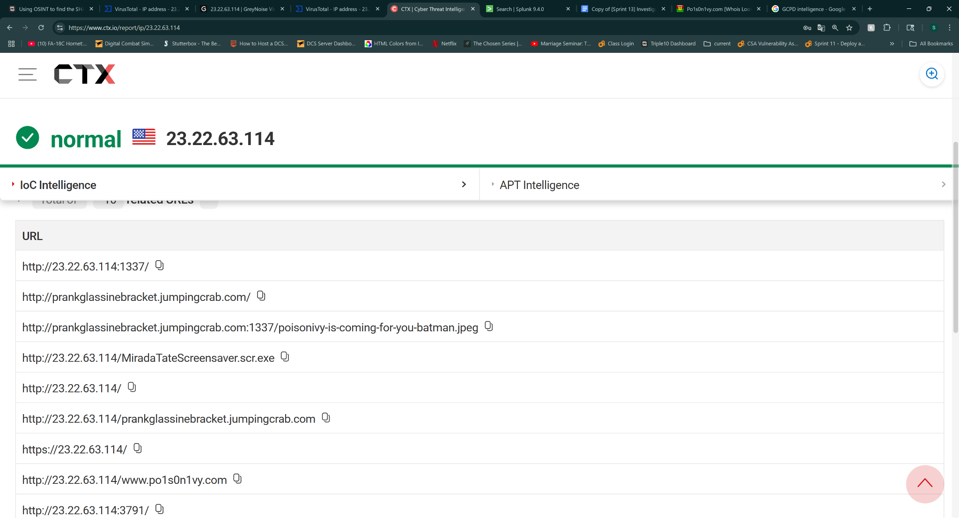

13.2.12 Custom hex

13.2.12 Figuring out the malware’s custom hex
Instructions for completing this task are located here. Use this worksheet to keep notes as you complete it.

Searching for MirandaTateScreensaver.scr.exe reveals its SHA256 hash, and viewing the community notes gives us the hex string

4e 65 6c 20 6d 65 7a 7a 6f 20 64 65 6c 20 63 61 6d 6d 69 6e 6f 20 64 69 20 6e 6f 73 74 72 61 20 76 69 74 61 20 6d 69 20 72 69 74 72 6f 76 61 69 20 70 65 72 20 75 6e 61 20 73 65 6c 76 61 20 6f 73 63 75 72 61

Which translates from hex to Nel mezzo del cammino di nostra vita mi ritrovai per una selva oscura
Which is the opening line in Dante’s Inferno (the book)

The Italian phrase "Nel mezzo del cammin di nostra vita mi ritrovai per una selva oscura" translates to "Midway upon the journey of our life, I found myself in a dark wood" in English, according to several literary sites. It is the famous opening line of Dante Alighieri's Inferno.

13.2.13 WHOIS info

13.2.13 Using OSINT to discover interesting WHOIS information
Instructions for completing this task are located here. Use this worksheet to keep notes as you complete it.

Community notes upon searching 23.22.63.114 on virusTotal result in a hex code

6c 61 73 63 69 61 74 65 20 6f 67 6e 69 20 73 70 65 72 61 6e 7a 61 2c 20 76 6f 69 20 63 68 27 69 6e 74 72 61 74 65

Which decoded reads

lasciate ogni speranza voi ch'intrate

Translated to english

Abandon all hope, ye who enter
From Dante’s Inferno

13.3 Analyzing the brute force attack

13.3.1 Passwords used

13.3.1 Identifying passwords used
Instructions for completing this task are located here. Use this worksheet to keep notes as you complete it.

index=client1 imreallynotbatman.com sourcetype="stream:http" http_method=POST dest_ip="192.168.250.70" src_ip="23.22.63.114" form_data="*passwd=*" | rex field=form_data "passwd=(?<extracted_password>\\w+)" |tail 1

Searching POST http requests from src_ip 23.22.63.114 returns form data in 412 entries.
Navigating to the first even using tail 1shows a login attempt using username admin and passwd 12345678

13.3.2 6-char passwords

13.3.2 Figuring out 6-character passwords
Instructions for completing this task are located here. Use this worksheet to keep notes as you complete it.

index="client1" source="stream:http" src_ip="23.22.63.114" http_method=POST passwd="passwd=" pass="*" | rex field=form_data "passwd=(?<userpassword>\w+)" | eval lenpword=len(userpassword) | where lenpword=6 | eval password_lower=lower(userpassword) | lookup coldplay.csv song AS password_lower OUTPUTNEW song | search song=* | table song | sort song

After parsing and extracting all 6 character passwords from POST form_data fields from src_ip 23.22.63.114, normalizing them to lowercase, and setting up a table of common Coldplay song titles, and referencing the results against that table, the song title “yellow” is the only hit.

13.3.3 Admin password

13.3.3 Establishing the correct admin password
Instructions for completing this task are located here. Use this worksheet to keep notes as you complete it.

Searching for POST requests by passwd use returned 412 entries with only one entry being reused

index=client1 imreallynotbatman.com sourcetype="stream:http" dest_ip="192.168.250.70" http_method="POST" form_data="*passwd=*" | rex field=form_data "passwd=(?<passwd>\w+)" | search passwd=batman

First case was User-Agent: Python-urllib/2.7 identified by https://user-agents.net/string/python-urllib-2-7 as being an entity associated with a web crawler bot.

Second use case was by Mozilla/5.0 (Windows NT 6.1; WOW64; Trident/7.0; rv:11.0) like Gecko

13.3.4 Average password length

13.3.4 Determining the average password length
Instructions for completing this task are located here. Use this worksheet to keep notes as you complete it.

After pulling http POST requests and extracting the passwd data using a rex command, the passwords used were then evaluated for length, averaged, and rounded to the nearest whole number

index=client1 imreallynotbatman.com sourcetype="stream:http" dest_ip="192.168.250.70" http_method="POST" form_data="*passwd=*" | rex field=form_data "passwd=(?<passwd>\w+)" | eval length=len(passwd) | stats avg(length) as avg_password_length | eval avg_password_length=round(avg_password_length)

This concludes with 6 being the average password length

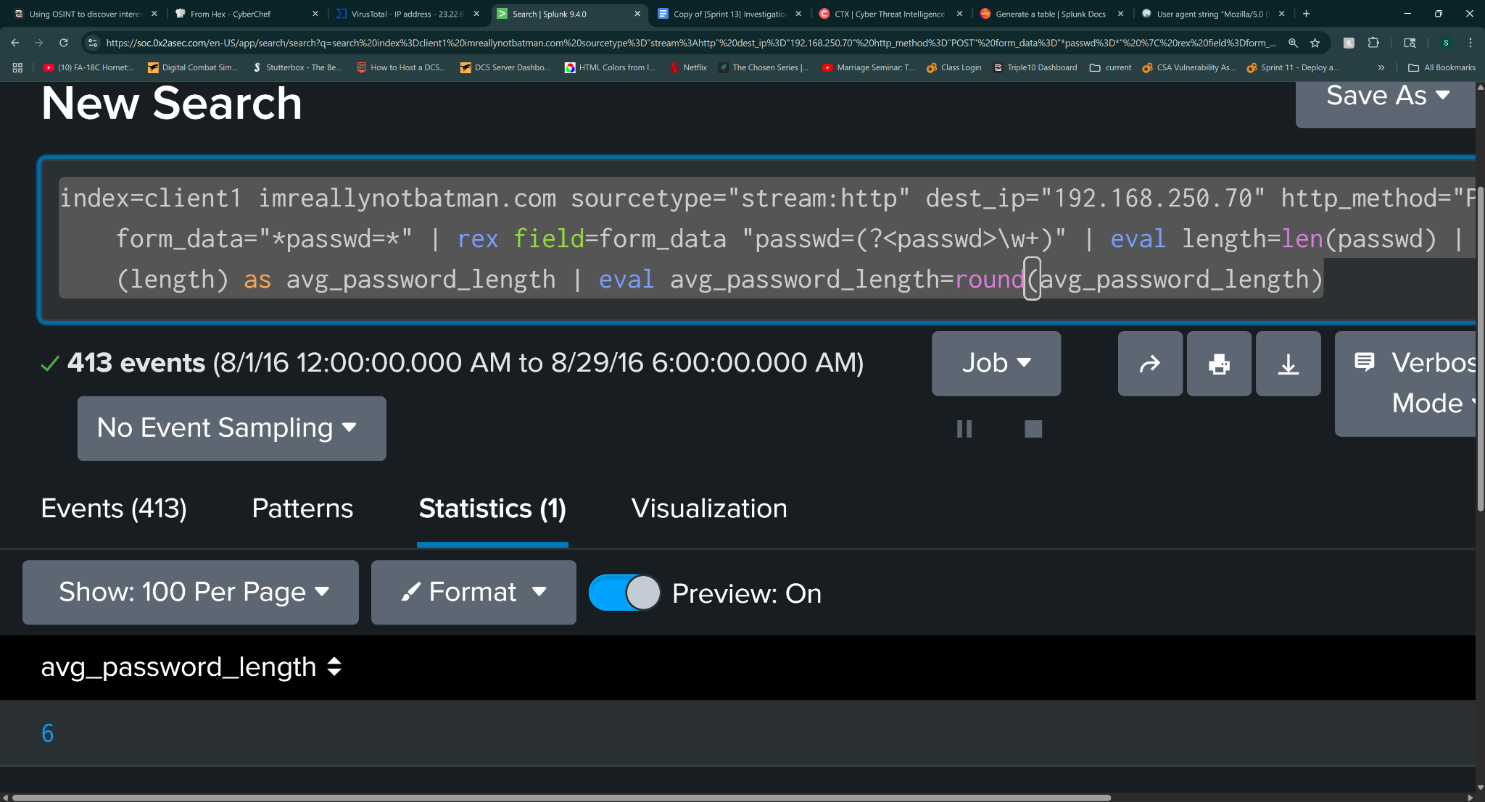

13.3.5 Seconds between events

13.3.5 Calculating seconds elapsed between two events
Instructions for completing this task are located here. Use this worksheet to keep notes as you complete it.

crafting the search criteria first by searching imnotreallybatman.com on sourcetype=http:stream for HTTP POST events by dest_ip 192.168.250.70 with form_data=”passwd=” From there form a regex expression to extract passwords used = rex field=form_data "passwd=(?<passwd>\w+)" and do a stats count by passwd to find the admin password - batman

Apply transaction to the search whic gives us a field and value of 92.169 which we use eval dur=round(duration, 2) to crate a new field called dur to show 92.17 - the rounded final value of 92.17

13.3.6 Unique password count

13.3.6 Reckoning the unique password count
Instructions for completing this task are located here. Use this worksheet to keep notes as you complete it.

Building on previous searches - searching HTTP POST commands containing username and passwords, but filtering to only attempts to the index.php but excluding Acunetix hits, file and user_agents that contain Python indicators or known malicious user agents. From there extracting form_data for passwd using a regex expression and removing duplicates using the dedup command, and finally using stats count to get a count of unique password attempts.

index=client1 imreallynotbatman.com sourcetype="stream:http" dest_ip="192.168.250.70" http_method="POST" form_data="*passwd=*" uri_path="/joomla/administrator/index.php" NOT "Acunetix" http_user_agent="Python-urllib/2.7" | rex field=form_data "passwd=(?<passwd>\w+)" | dedup passwd |stats count

Total number is 412.

13.4 Digging in deeper

13.4.1 Host IP

13.4.1 Determining a host’s IP address
Instructions for completing this task are located here. Use this worksheet to keep notes as you complete it.
First began by searching sysmon logs for desired hostname, within a time constraint of 8-24 from hours 0000 to 2359. From there filtered to xmlwineventlog and further filtered to eventID= 3. Crafted a regex expression to extract SourceIp values into a new field and then do a stats count by sourceIp to show which value is most prevalent.

There were 5 entries with one having 99% of the total count - 192.168.250.100 - an internal ip, with the matching desired hostname logged.

index=client1 source="WinEventLog:Microsoft-Windows-Sysmon/Operational" host=we8105desk sourcetype=xmlwineventlog | rex max_match=1 "<Data Name='SourceIp'>(?<SourceIp>[^<]+)" | search SourceIp="192.168.250.100"

13.4.2 Least frequent alert

13.4.2 Calculating the least frequent alert
Instructions for completing this task are located here. Use this worksheet to keep notes as you complete it.

This one is pretty simple. Were looking through Suircata logs for a event ID that relates to a malware called “cerber”

Searching that alone return 5 results

Add | stats count by alert.signature, alert.signature_id to show a table of results. Sort the results in ascending value, and return only the first hit.

index=client1 sourcetype=suricata "cerber" | stats count by alert.signature, alert.signature_id | sort count asc | head 1

The alert.signature_id field with the least number of hits is our target.

2816763

13.4.3 Ransomware FQDN

13.4.3 Working out which FQDN the ransomware redirects to
Instructions for completing this task are located here. Use this worksheet to keep notes as you complete it.

Start by pivoting off dns logs using sourcetype=”stream:dns” and filtering on src_ip=”192.168.250.100” The IP of our known infected workstation. Filter traffic to only Aug 24 for a 24 hr period of time. And only query_type=A

From there we use 3 NOT commands to filter out local domains, microsoft, and google domain searches and make a table to examine the remaining entries by using | table _time query{}

index=client1 sourcetype=stream:dns query_type=A NOT query{}="*.microsoft.com" NOT query{}="*.google.com" NOT query{}="*.waynecorpinc.local" src_ip="192.168.250.100" | table _time, query{}

Cerberhhyed5frqa.xmfir0.win is our answer

13.4.4 Malicious URL by host

13.4.4 Discovering the first malicious URL visited by a host
Instructions for completing this task are located here. Use this worksheet to keep notes as you complete it.

Working backwards we search the index by host=”we8105desk” and do a stats count to find the highest hit count to confirm the IP address used by the workstation. 192.168.250.100 Then we filter for sourcetype=stream:dns and query_type=A

Once that is formed, we use | reverse to order the results from earliest to latest to find the first occurrence then filter out known good domains.

From there we scan and research the hits that are left from threat intelligence websites. Researching the first couple shows that solidaritedeproximite.org has several redacted fields, leading me to believe it is the malicious domain. Researching it on virustotal hits on two files communicating with this domain that are known malware.

13.4.5 VB script run during infection

13.4.5 Locating the VB script run during infection
Instructions for completing this task are located here. Use this worksheet to keep notes as you complete it.

First move to source="WinEventLog:Microsoft-Windows-Sysmon/Operational" using earliest=0 to search all logs on the target date of 08-24-2016. Add a search term (vbscript OR .vbs) .exe to find VBScript entries in logs.

Next create a rex expression to find a single entry with EventID=1 that matches prior criteria, has Command_line field data and pulls those field datasets into a new field.

Next i used eval and len to create a new field that measures the length of the Command_line field and then create a table showing the Command_line a script length fields to compare entries and find the entry with the full command line and the vbs script 20429.vbs

index=client1 earliest=0 source="WinEventLog:Microsoft-Windows-Sysmon/Operational" (vbscript OR .vbs) .exe EventCode=1 | rex max_match=1 "<EventID>(?<EventID>\d+)</EventID>"
| search EventID=1
| rex max_match=1 "<Data Name='CommandLine'>(?<CommandLine>[^<]+)" | eval script_field_length = len(CommandLine)
| table _time, host, CommandLine, script_field_length

13.4.6 USBs

13.4.6 Digging up evidence of USBs connected to a device
Instructions for completing this task are located here. Use this worksheet to keep notes as you complete it.

For searching for removable storage we pivot off of WinRegistry logs focused on the infected host. Labels for removable media are stored in the registry_value_data field, and can be found also by the keyword friendlyname. Locating these logs and inspecting the key path will reveal clues to removable storage. Further inspection of the log will show a field of data=”*” which contains our label name

index=client1 host="we8105desk" sourcetype=WinRegistry friendlyname

13.4.7 File server

13.4.7 Identifying the file server
Instructions for completing this task are located here. Use this worksheet to keep notes as you complete it.

Finding the file server bob was connected to is simple. Pivot off of the hostname and sourcetype= stream:smb, filtering by src_ip=”bobs ip 192.168.250.100” and getting a stats count by dest_ip

index=client1 sourcetype="stream:smb" src_ip="192.168.250.100" | stats count by dest_ip

192.168.250.20 has the most hits

Double checking this can be done by viewing the registry entries for bobs machine and using the keyword “fileshare” to find key data that contains the suspected IP revealed in the previous step

index=client1 host="we8105desk" sourcetype=WinRegistry fileshare
| head 1

The key data shows the IP address and hits on the keyword “fileshare”

13.4.8 Unique files

13.4.8 Computing unique files encrypted by the ransomware
Instructions for completing this task are located here. Use this worksheet to keep notes as you complete it.

START BY LOSING YOU BRAIN
And using Xmlwineventlogs to search src ip 192.168.250.100 and dest ip 192.168.250.20 to find logs that include DESTINATIONHOSTNAME= field data in raw logs to find the servers hostname.

From there realize you wasted 2 hrs looking for that, and then search | where like(Relative_Target_Name, "%.pdf") to find entries on modified *.pdf files

Then use stats dc on Relative_Target_Name to find the total number of unique file modification entries
Created a table to show the count.
Sometimes ransomware breaks file headers, so add app=”win:unknown” to the search query to catch broken files

13.4.9 Process

13.4.9 Tracking down the responsible process
Instructions for completing this task are located here. Use this worksheet to keep notes as you complete it.

Start with finding the file that originally was ran to start the infection. During previous searches for the vbs file, we found a file named 121214.tmp

From those results we formed a series of regex max match commands that pull data from _time, ProcessId, ParentProcessId, Image, CommandLine, ParentImage, ParentCommandLine fields so they can be displayed in a table and then sorted to ascending order with sort asc.

Examining this output reveals that Wscript.exe ran 20429.vbs, which spawned cmd.exe and ran 121214.tmp

index=client1 sourcetype="xmlwineventlog" "121214.tmp" | rex max_match=1 "<Data Name='ProcessId'>(?<ProcessId>[^<]+)"
| rex max_match=1 "<Data Name='ParentProcessId'>(?<ParentProcessId>[^<]+)"
| rex max_match=1 "<Data Name='Image'>(?<Image>[^<]+)"
| rex max_match=1 "<Data Name='CommandLine'>(?<CommandLine>[^<]+)"
| rex max_match=1 "<Data Name='ParentImage'>(?<ParentImage>[^<]+)"
| rex max_match=1 "<Data Name='ParentCommandLine'>(?<ParentCommandLine>[^<]+)"
| table _time, ProcessId, ParentProcessId, Image, CommandLine, ParentImage, ParentCommandLine | sort _time asc

Wscript.exe processID is 3968

13.4.10 Counting files

13.4.10 Calculating the number of encrypted files of a specific format
Instructions for completing this task are located here. Use this worksheet to keep notes as you complete it.

Here we are searching for logs showing an EventID of 2, meaning file modification and timestamp change. Using regex to pull all logs with an eventID field and filter to EventID 2. From there we examine those logs to find ones that include a file name with .txt file extension, effectively gathering the number .txt files that were modified or encrypted during the ransomware infection based on the number of hits returned

index=client1 source="WinEventLog:Microsoft-Windows-Sysmon/Operational" | rex max_match=1 "<EventID>(?<EventID>\d+)</EventID>"
| where EventID=2 | rex field=_raw "<Data Name='TargetFilename'>(?<TargetFilename>[^<]+)</Data>"
| where like(TargetFilename, "C:\\Users\\bob.smith.WAYNECORPINC\\%.txt")

13.4.11 Cryptor's filename

13.4.11 Locating the cryptor’s filename
Instructions for completing this task are located here. Use this worksheet to keep notes as you complete it.
85.93.43.236

Idk how but its mhtr.jpg

13.4.12 Obfuscation

13.4.12 Using OSINT to determine the ransomware’s obfuscation technique
Instructions for completing this task are located here. Use this worksheet to keep notes as you complete it.

Its stenography - code hidden in images

